

**Have Medicaid?**

**Take 3 Steps to Keep Your Coverage.**

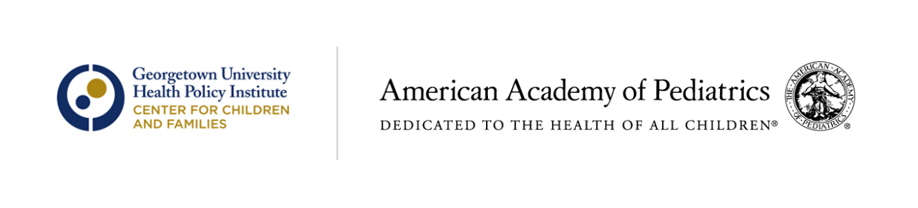­

**UPDATE YOUR INFO**

Make sure Medicaid has your current contact information. Visit [**mn.gov/dhs/mycontactinfo**](https://mn.gov/dhs/mycontactinfo/) or call **(800) 657-3672**.

**REPLY ASAP**

Respond right away with updated info to ensure you and your family are still eligible.   
Learn more at [**mn.gov/dhs/renewmycoverage**](https://mn.gov/dhs/renewmycoverage/)**.**

**LOOK OUT**

Check for official information   
(mail and text messages) with instructions on when and how to renew coverage.

**1**

**2**

**3**

**NO LONGER QUALIFY FOR MEDICAID?**

**Children:**Most kids can still be covered through the Children’s Health Insurance Program / **Medical Assistance**. For details, check your Medicaid notice or call **800-657-3739** for more information.

**Adults:**Adults may be able to get financial assistance to pay for a health insurance plan through **MNSure**. Visit **www.mnsure.org** or call **855-366-7873** to apply.

**Questions? Call (800) 657-3672**