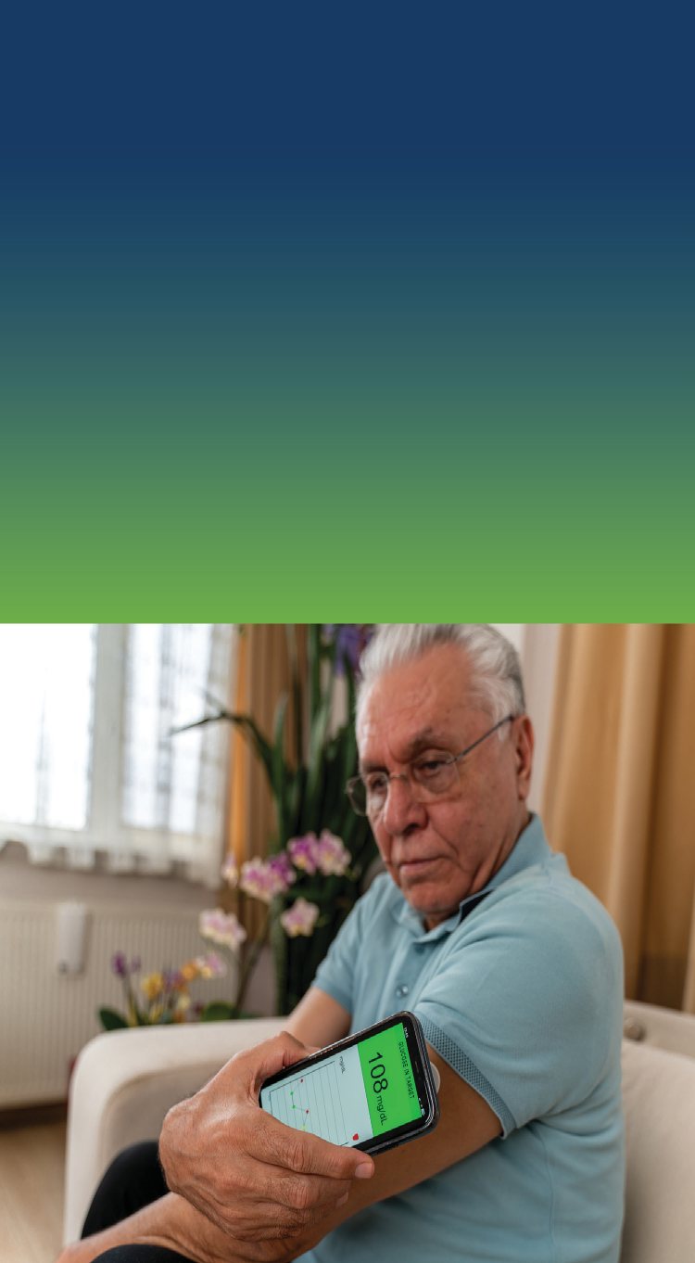
Keep your health insurance
Do you have Medical Assistance or MinnesotaCare?
You can now get text messages when you need to take action to keep your insurance.
Update your contact information to get texts.

Learn more at: mn.gov/dhs/renewmycoverage

