Badging icon keys
 = Anytime Learning
 = Child Care Center Licensing
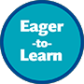 = Eager To Learn
 = Family Child Care Licensing

