## Medical Assistance (MA)

1. What is the percentage of individuals who are “Aged/Blind/Disabled” in managed care vs. fee for service in Minnesota?
   1. In 2014, among those eligible for MA under the category of aged (over 65 years old), blind, or disabled, about 51 percent were covered as fee for service and 49 percent were served by managed care organizations.
2. What maintenance of effort requirement do we have for MA and when does it expire?

The Affordable Care Act (ACA) requires the state to maintain MA & CHIP income levels for children under age 19 through Sept. of 2019. A maintenance of effort also applies as a condition of CHIP funding. The state must maintain Medicaid income levels for children under age 19 and for pregnant women that were in effect on June 1, 1997 (including income levels under section 1115 waivers).

1. What is the financial exposure of the state when we go from 100% FMAP to 90% FMAP in the MA expansion group?
   1. The federal share of MA expansion costs goes from 100% to 95% in CY 2017, 94% in CY 2018, 93% in CY 2019, and 90% in CY 2020 and beyond. The chart below shows the projected federal and state share for the MA expansion population by fiscal year from the current forecast.

|  |  |  |  |  |
| --- | --- | --- | --- | --- |
| **Medical Assistance Expansion Population**  **February 2015 Forecast Projections (in millions)** | | | | |
| **FY** | **Projected Cost** | **Federal Share** | **State Share** | **FMAP** |
| 2016 | 2,187 | 2,181 | 6 | 100.0% |
| 2017 | 2,106 | 2,048 | 57 | 97.5% |
| 2018 | 2,138 | 2,015 | 120 | 94.5% |
| 2019 | 2,232 | 2,082 | 147 | 93.5% |

* 1. As an illustration, if the projected total costs for the MA expansion group of $2.23 billion in FY2019 remain the same over the next two fiscal years, the state share would be $190 million in FY2020 (91.5% FMAP) and $223 million (90% FMAP) in FY2021.

**MinnesotaCare**

1. Do we have a maintenance of effort requirement for MinnesotaCare?
2. No.
3. What is the history behind Minnesota’s establishment of a basic health plan? Why did the state not use a section 1115 waiver to maintain MinnesotaCare?
4. In 2011, Governor Dayton appointed the Health Care Reform Task Force to provide recommendations on the implementation of the ACA. This task force recommended the state provide additional supports or establish a basic health plan instead of moving the MinnesotaCare population into the new exchange. In 2013, the state legislature passed legislation to convert MinnesotaCare from a section 1115 waiver program under Medicaid to a basic health plan under the ACA.
5. After the passage of the ACA, CMS placed an auto-expiration date of Dec 31, 2013 on section 1115 waivers, including the MinnesotaCare program waiver. Since the establishment of a basic health plan in Minnesota, CMS has approved several section 1115 waivers in other states, most of which have been alternatives to the Medicaid expansion option under the ACA.
6. What is the attrition (churn?) rate since premiums were raised in MinnesotaCare? Have we seen more disenrollment or payment non-compliance?
   1. It is too early to make reliable assumptions about attrition rates related to increased premiums that went into effect in August.
7. Please provide some background on the history of the spending on MA that comes from the Health Care Access Fund (HCAF).
   1. There are two uses related to MA in the HCAF for FY18-19 biennium:
      1. The first is an appropriation that pays for a portion of the costs of MA, which began in 2014 and is estimated to be $529 million in FY18-19. The purpose was to pay for some of the costs to the General Fund from the eligibility realignment and expansion in MA and MinnesotaCare during the implementation of the ACA. The value of this appropriation has been adjusted over time as available resources in HCAF have changed.
      2. The second use is a contingent transfer to the General Fund from the HCAF. This transfer does not directly impact MA spending across funds, but rather acts as revenue to the General Fund. This transfer originated in 2003 when the provider tax and HMO tax were extended to MA enrollees.
   2. As the figure below illustrates, there is a long history of the legislature transferring funds from the HCAF to the General Fund. These transfers are generally associated with eligibility or benefit changes which increase expenditures for health care programs in the General Fund. However, spending directly for MA is a relatively new application of HCAF resources.

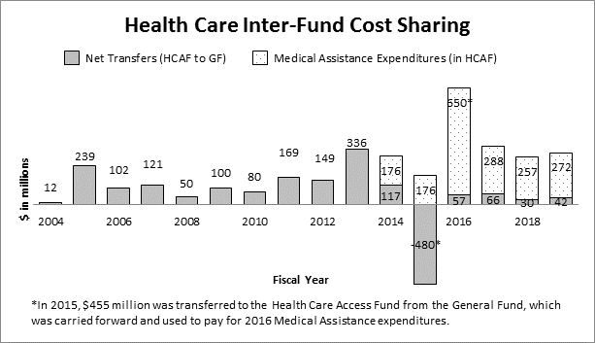

**Eligibility Rules**

1. What are the new rules for children receiving health insurance through their parent’s health insurance policy? Why is there coverage under MinnesotaCare for 19 and 20 year olds who fall within the income range of 133% FPL to 200% FPL?
   1. In general, children can remain on (or be added to) a parent’s health insurance policy until they turn 26 years old.
   2. If a young adult, 19 or 20 years old, is claimed as a tax dependent by her parents and has access to, or is eligible for, coverage through her parent’s health insurance policy, then she is ineligible for MinnesotaCare.
   3. While MA is available for children under the age of 19 with family income up to 275% FPL, young adults, who are 19 or 20 years old, can qualify for MA with income up to 133% FPL. These young adults, along with parents and adults without dependent children, become eligible for MinnesotaCare, when their incomes increase above 133% FPL, but no higher than 200% FPL.
2. What is the difference between projected and current income? Which programs use projected? How is projected annual income validated?
   1. Projected annual income is based on income expected for a tax (or calendar) year.  Current income, used in MA, is based on the current month’s income at the date of application, which is then used to estimate one’s annual income by multiplying that month’s income by 12.
   2. MinnesotaCare and plans purchased through MNsure with advanced premium tax credits use projected (tax year) annual income to determine eligibility, whereas MA uses current income.
   3. A person’s attestation of income is compared to electronic data sources including federal tax income filings, a national wage data base known as TALX, and income sources from the Department of Employment and Economic Development (DEED).