Health Care Financing Task Force

Vision:
Sustainable, quality health care for all Minnesotans.

Guiding Principles:

Realistic
The task force will make recommendations that can realistically be implemented.

High Value Impact
The task force will seek recommendations that have high value and are meaningful to Minnesota’s health care reform efforts.

Holistic Perspective
The Task Force understands that health care finance and our recommendations do not exist in a vacuum, and are components of the health care and population health systems.

Focus
The task force recognizes that health care financing and system reform is extremely complex and it will contribute to the broader policy debates by focusing its time and attention on the issues it is charged with addressing.

Innovation
The task force is encouraged to identify opportunities for innovation in Minnesota’s health care financing and delivery systems which show promise for lowering costs, improving population health and improving the patient experience.

Workgroup Categories:
#1 - Health Care Delivery Design & Sustainability
#2 - Seamless Coverage Continuum and Market Stability
#3 - Barriers to Access
Charge:
Within the context of the triple aim, The Health Care Financing Task Force will develop innovative recommendations in order to create a health care financing and delivery system which:
- Provides seamless access to health care insurance across the public programs and private markets;
- Reduces barriers to accessibility and affordability of coverage, including transitions from the public to private markets;
- Addresses sustainable financing of health insurance programs, including their impact on the state budget;
- Assesses the impact of innovative financing options for reducing health disparities;
- Develops or expands innovative health care purchasing and delivery system strategies that reduce cost and improve health;
- Promotes effective and efficient alignment of program resources and operations;
- Increases transparency and accountability of program operations.
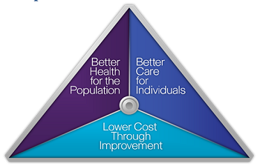
Triple Aim

