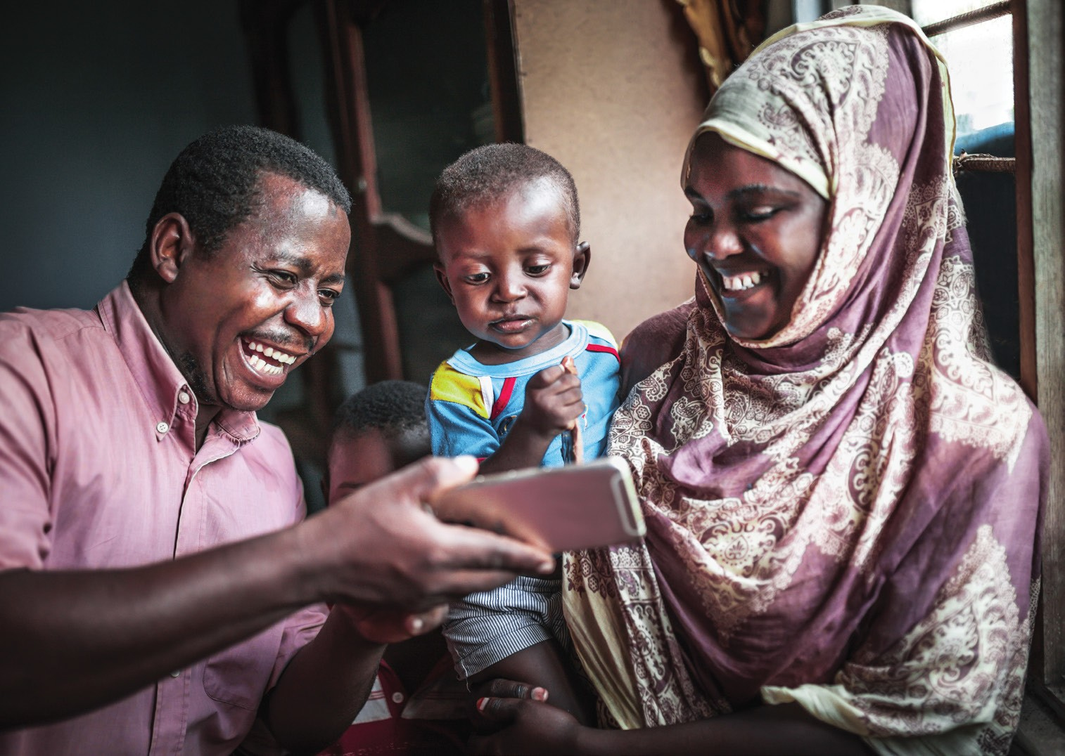
Ilaalso caymiskaaga caafimaad
Ma leedahay Caawimaad Caafimaad (Medical Assistance) ama MinnesotaCare?

Waxaad hadda heli kartaa fariimaha qoraalka
ah marka aad u baahan tahay inaad tallaabo qaado si aad u ilaalsato caymiskaaga.

Dib-u-cusbooneysii macluumaadkaaga xiriirka si aad u hesho farriimo qoraal ah.

Wax badan ka barta mn.gov/dhs/renewmycoverage

